**Jenkins Task -3**

**1) Create one jenkins job using the below code and create three stages. stage1: Git clone to download the source code. stage2: Sonarqube Integration to check the quality of code stage3: Slack Integration to send the alerts to slack. URL:** [**https://github.com/betawins/VProfile-1.git**](https://github.com/betawins/VProfile-1.git)

**2) Create one jenkins job using the below code and create three stages. stage1: Git clone to download the source code. stage2: Sonarqube Integration to check the quality of code stage3: Slack Integration to send the alerts to slack. URL:** [**https://github.com/betawins/hiring-app.git**](https://github.com/betawins/hiring-app.git)

Step:1

Launch two instances 1. Jenkins 2 SonarQube

Install Jenkins in Jenkins server

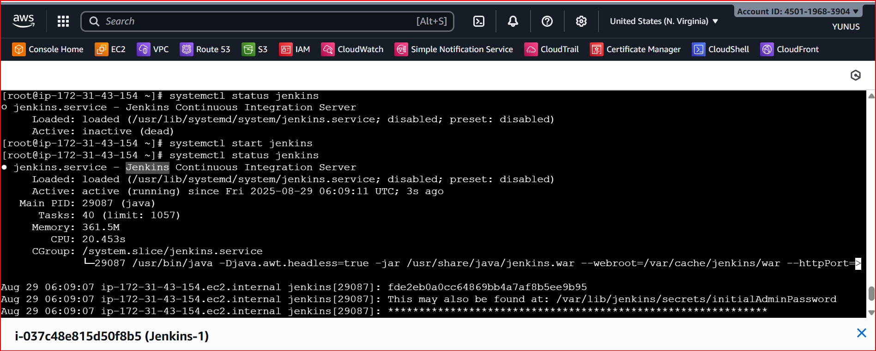

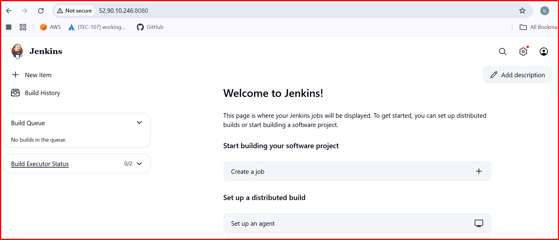

Install SonarQube in SonarQube Server

Installation of SonarQube:

Prerequisites

EC2 instance with Java installed

Use t2.large with atleast 20gb memory to run sonarqube.

MySQL Database Server or MyQL RDS instance.

1.Install Java

yum install java-1.8*

Add mysql rpm Repository

yum update

sudo wget https://dev.mysql.com/get/mysql57-community-release-el7-11.noarch.rpm

sudo yum localinstall mysql57-community-release-el7-11.noarch.rpm

rpm --import https://repo.mysql.com/RPM-GPG-KEY-mysql-2022

sudo yum install mysql-community-server

sudo systemctl start mysqld.service

systemctl start mysqld

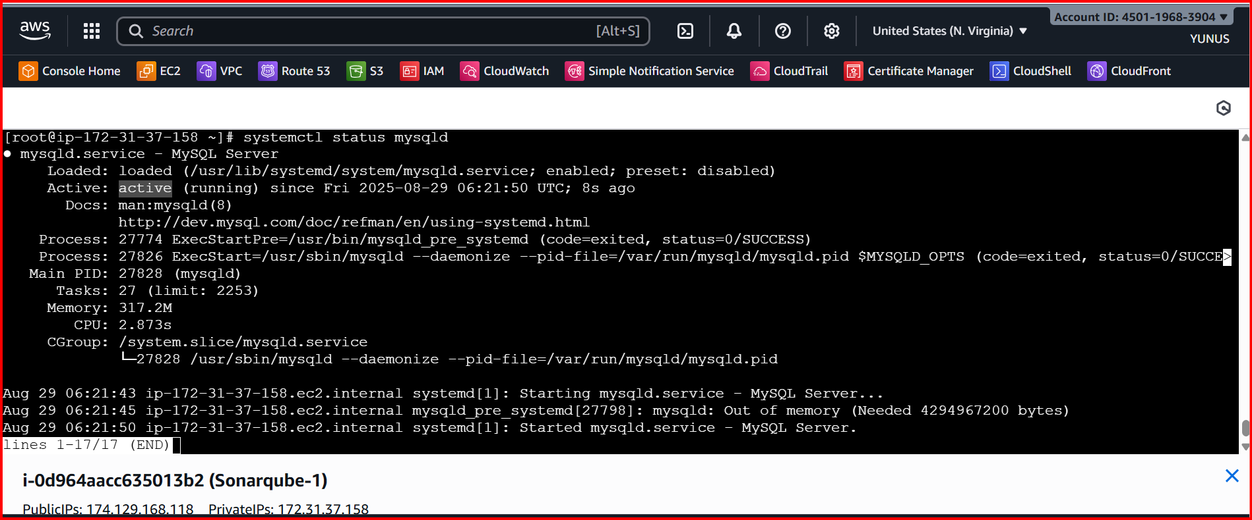

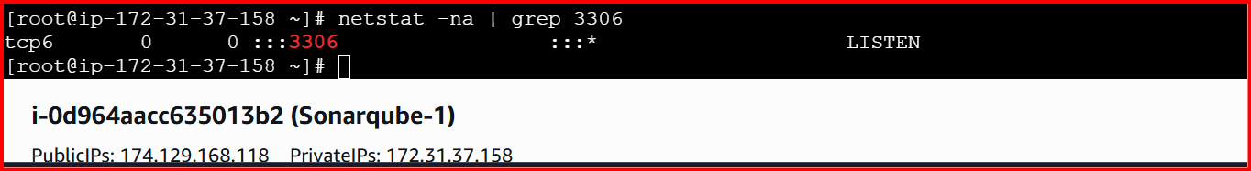

Configure the MySQL Root Password

You will see default MySQL root password: grep 'temporary' /var/log/mysqld.log

Login to mysql using the default password

mysql -u root -p

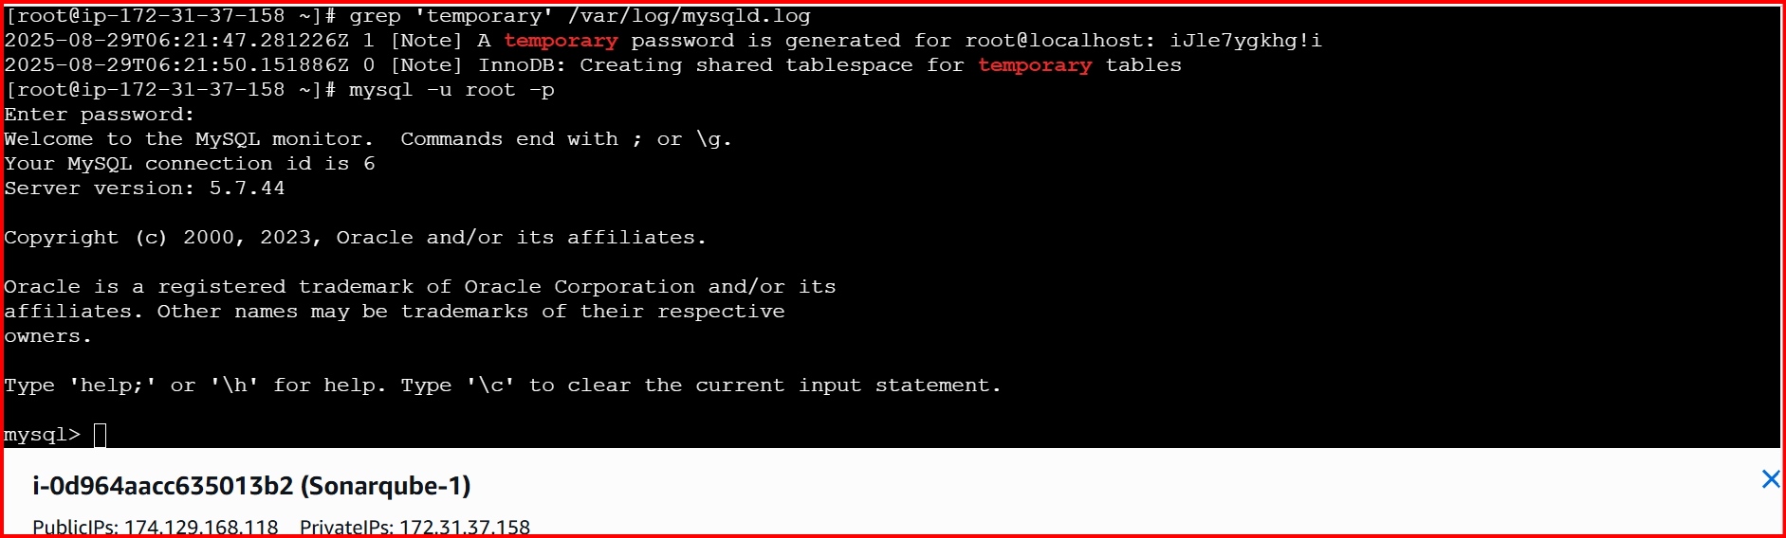

Now replace the default password with a new and strong password

ALTER USER 'root'@'localhost' IDENTIFIED BY 'Admin@123';

flush privileges;

exit

login with new password

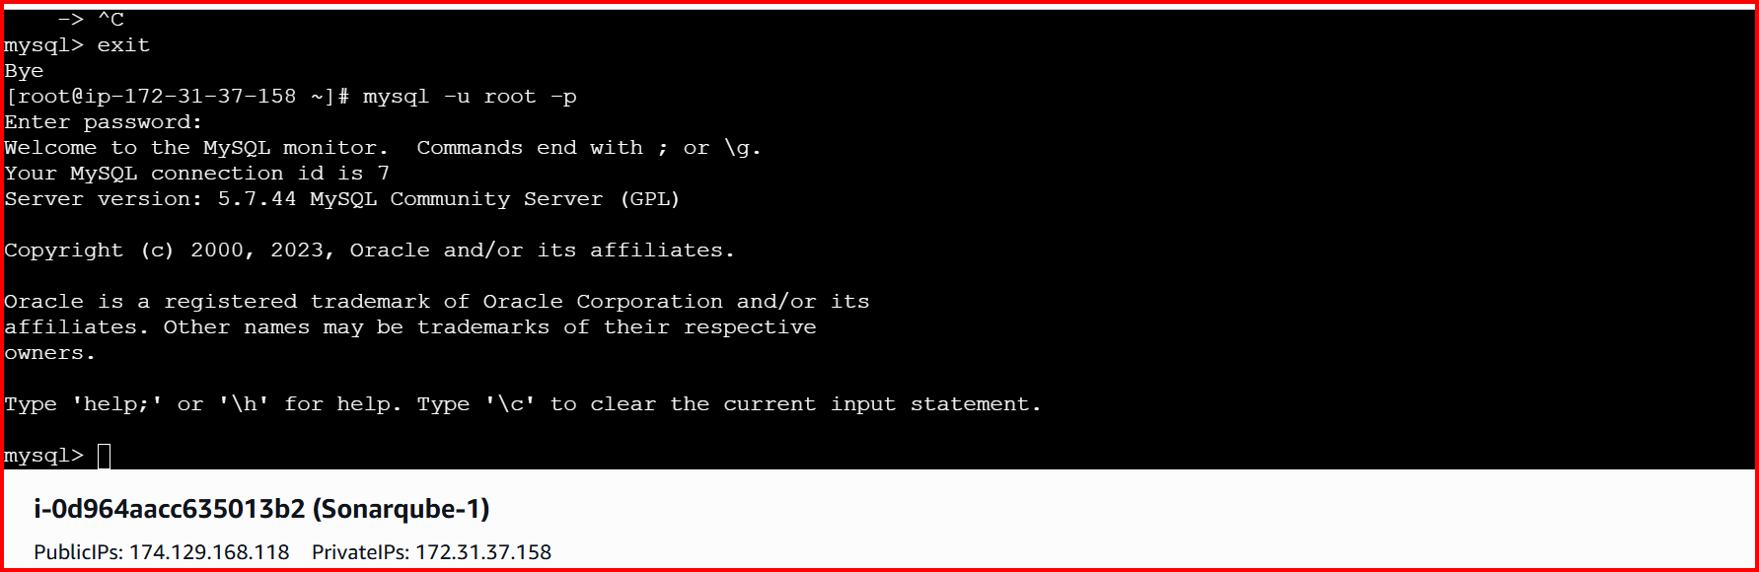

Download stable SonarQube:

wget https://binaries.sonarsource.com/Distribution/sonarqube/sonarqube-6.6.zip

unzip sonarqube-6.6.zip

mv /opt/sonarqube-6.6 /opt/sonar

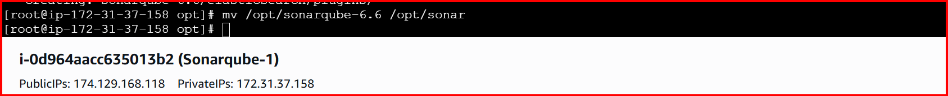

Login to Mysql : mysql -u root -p / password Admin@123

Create a new sonar database

CREATE DATABASE sonar CHARACTER SET utf8 COLLATE utf8_general_ci;

Create a local and a remote user

CREATE USER sonar@localhost IDENTIFIED BY 'Sonar@123';

CREATE USER sonar@'%' IDENTIFIED BY 'Sonar@123';

Grant database access permissions to users

GRANT ALL ON sonar.* TO sonar@localhost;

GRANT ALL ON sonar.* TO sonar@'%';

check users and databases

show databases;

SELECT User FROM mysql.user;

FLUSH PRIVILEGES;

QUIT

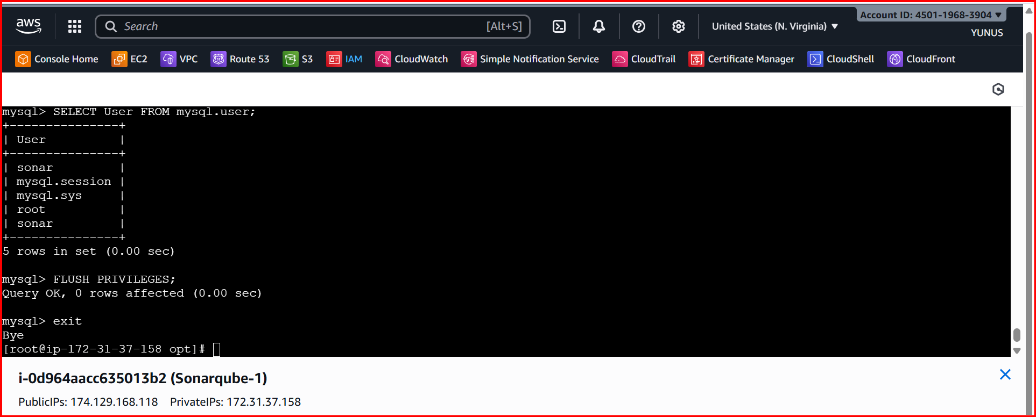

Edit sonar properties file

Location: cd /opt 🡪Cd sonar/🡪Cd conf/ 🡪vi sonar.properties

Make sure to check all the below lines

sonar.jdbc.username=`sonar`

sonar.jdbc.password=`Sonar@123`

sonar.jdbc.url=jdbc:mysql://`localhost:3306`/sonar?useUnicode=true&characterEncoding=utf8&rewriteBatchedStatements=true&useConfigs=maxPerformance&useSSL=false

sonar.web.host=`0.0.0.0`

sonar.web.context=`/sonar`

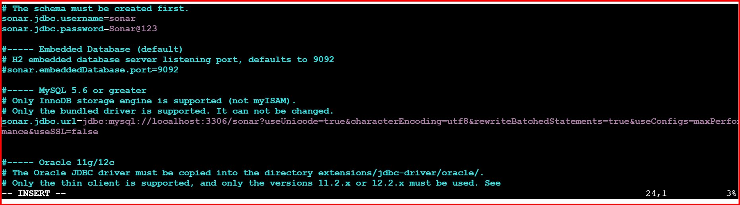

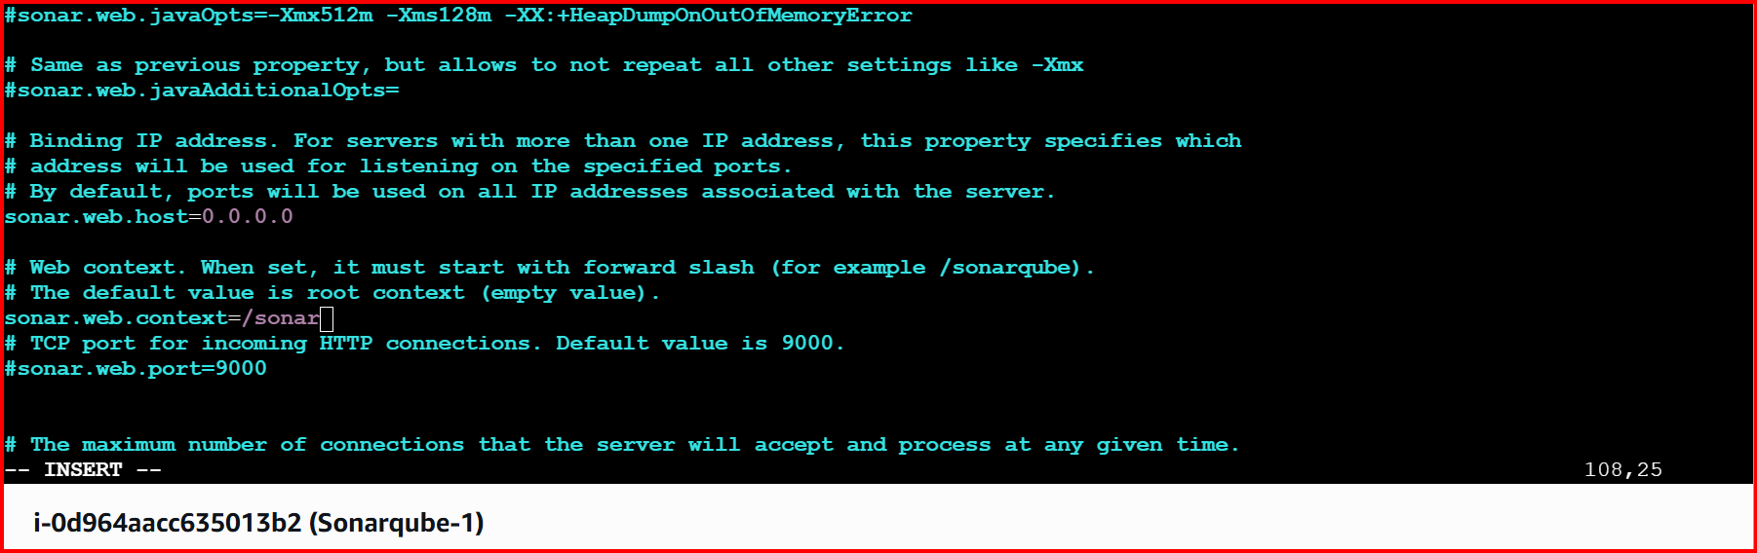

Start SonarQube service

Cd /

./sonar.sh start

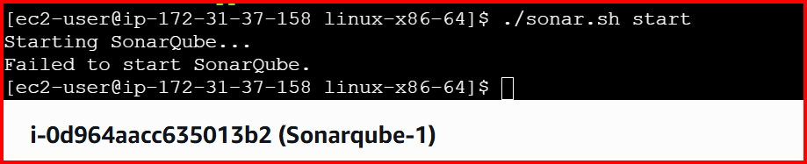

Change the permissions

Sudo chown -R ec2-user:ec2-user sonar

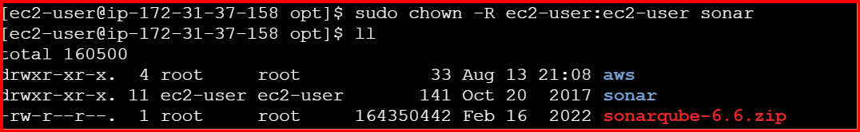

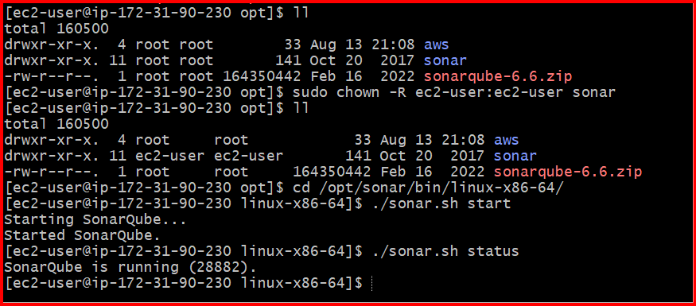

In Browser <http://3.80.148.153:9000/sonar>

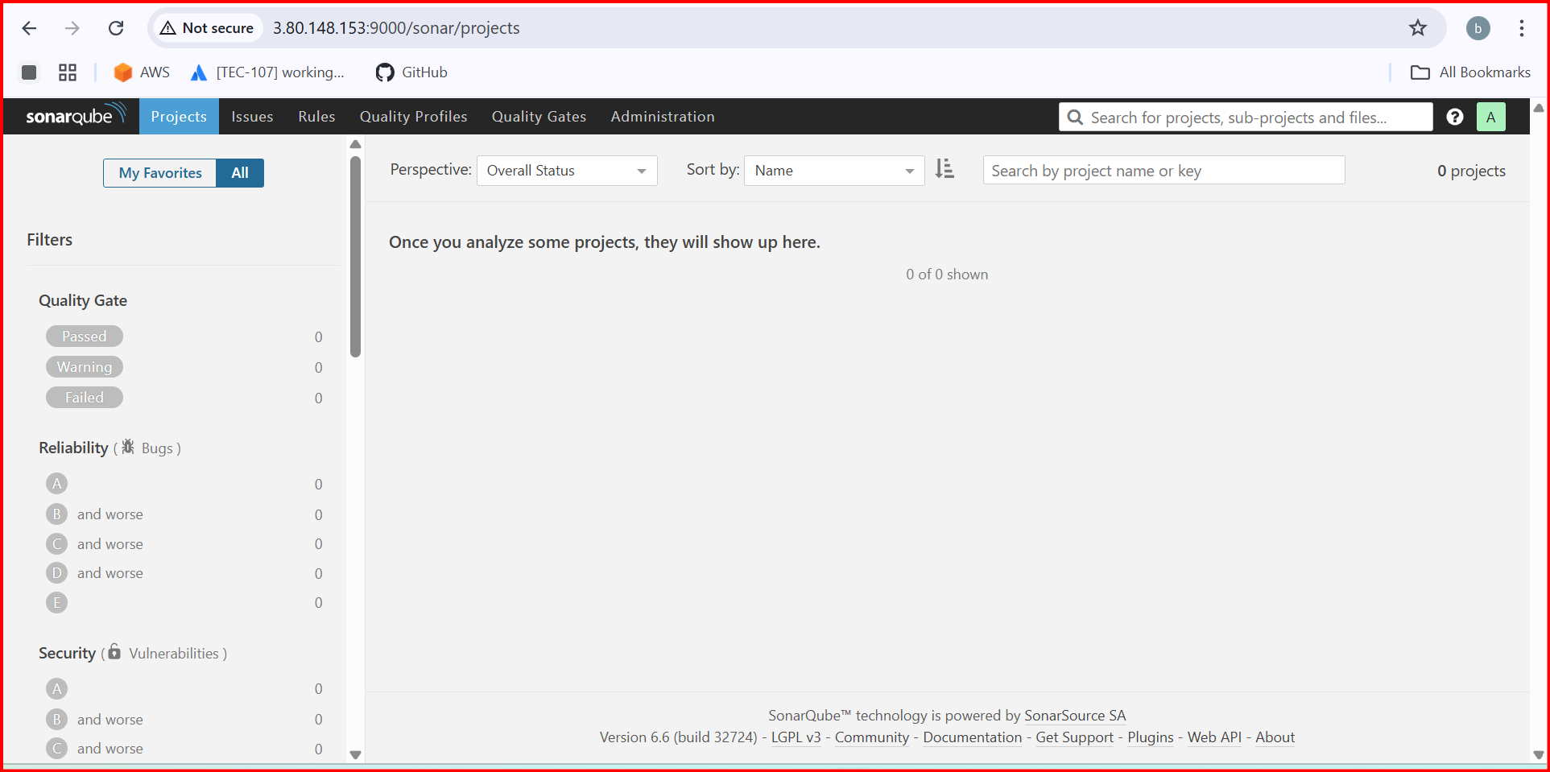

Download sonarqube scanner

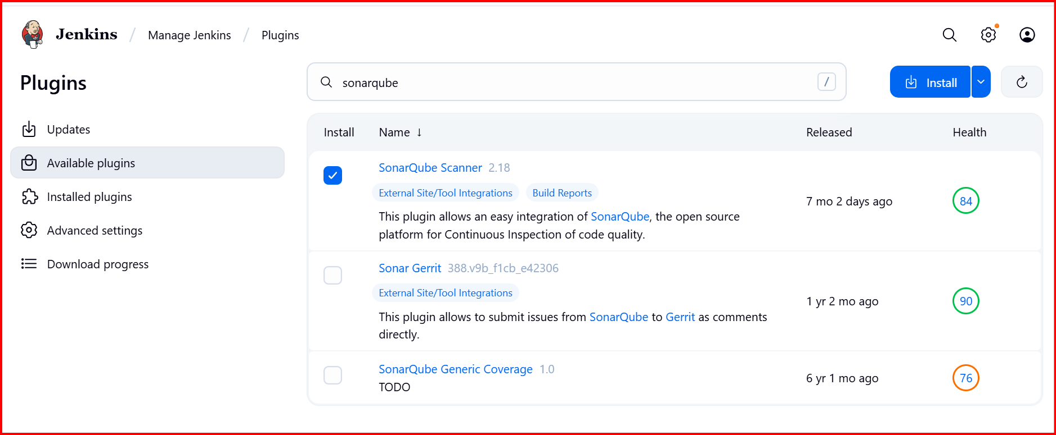

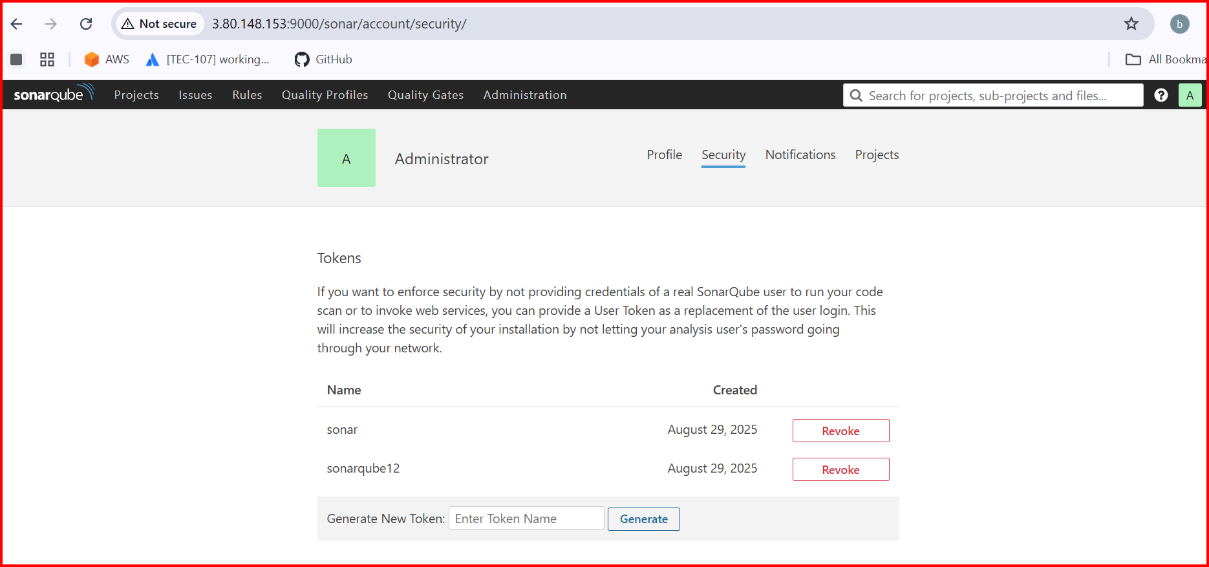

Create credentials in Jenkins token should be generated in sonarqube

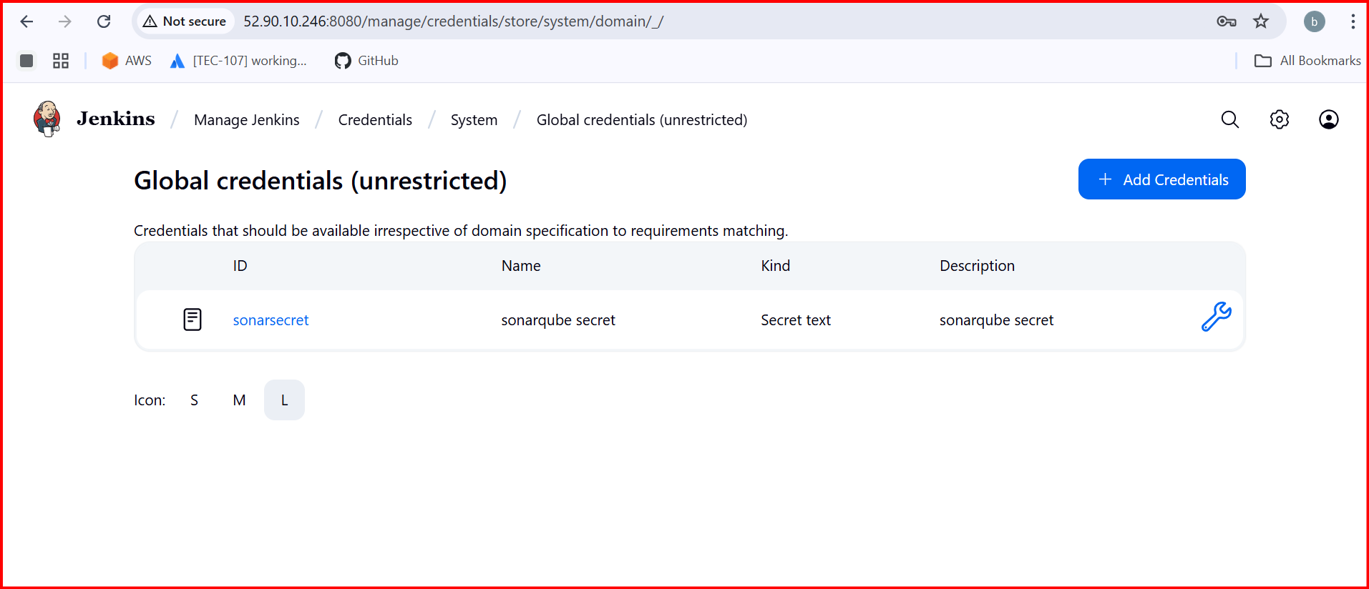

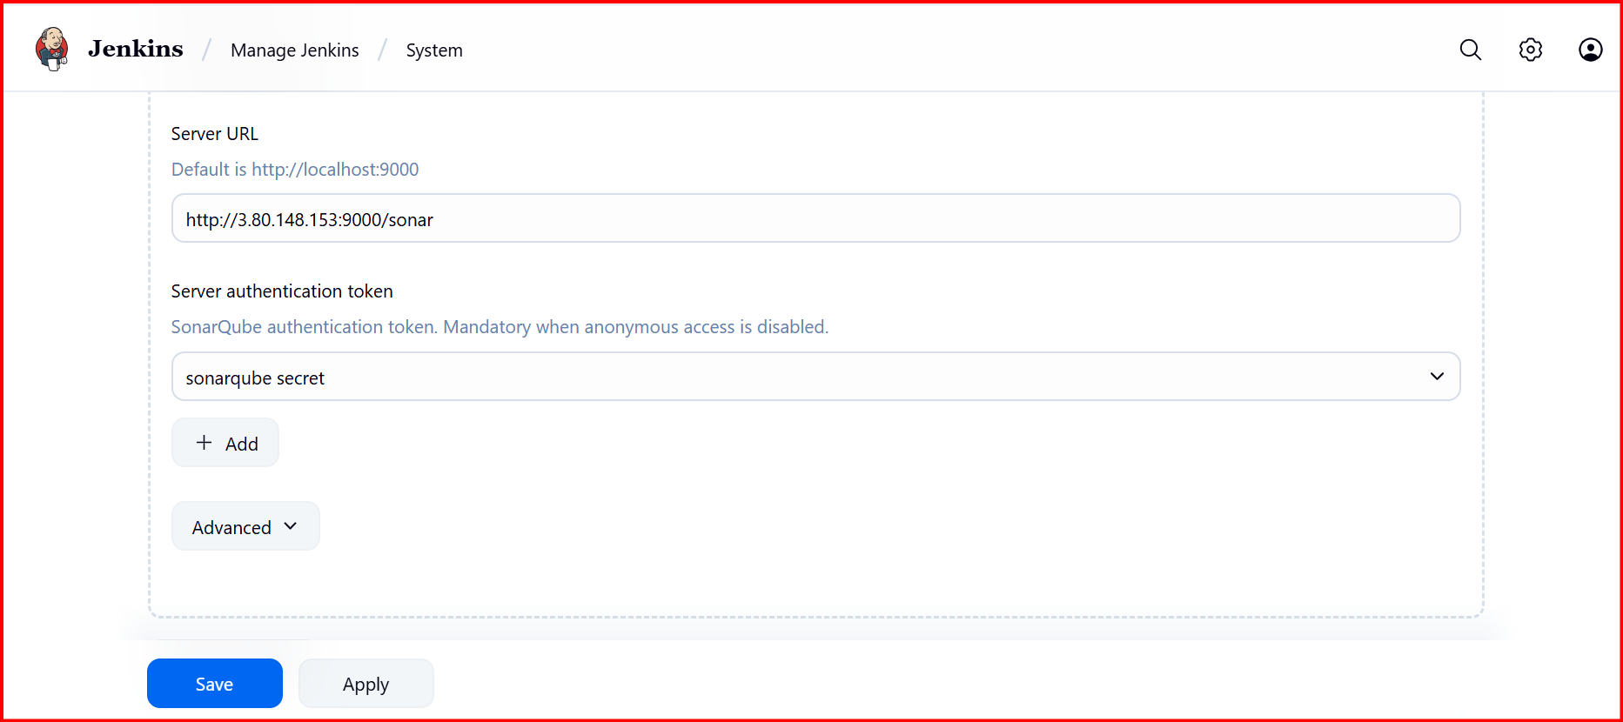

In Jenkins Server

Download the sonarsccaner

wget https://binaries.sonarsource.com/Distribution/sonar-scanner-cli/sonar-scanner-cli-4.6.2.2472-linux.zip

unzip sonar-scanner-cli-4.6.2.2472-linux.zip

mv sonar-scanner-4.6.2.2472-linux /opt/sonar_scanner

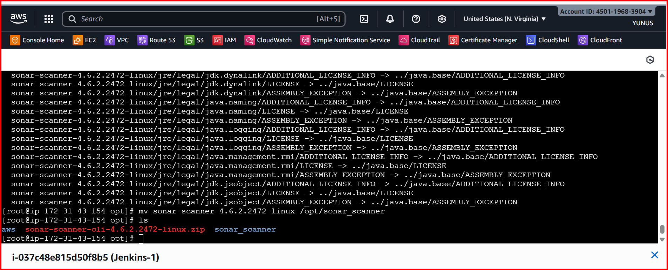

cd sonar_scanner/ 🡪 cd conf/ 🡪 vi sonar-scanner.properties

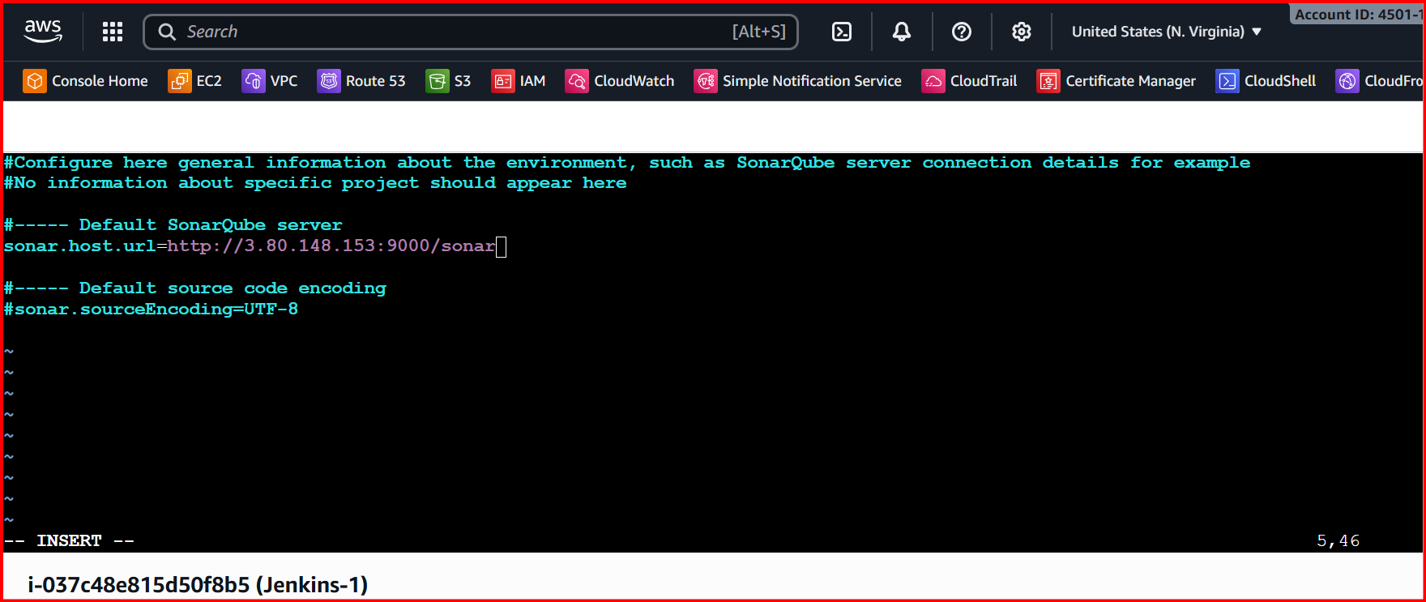

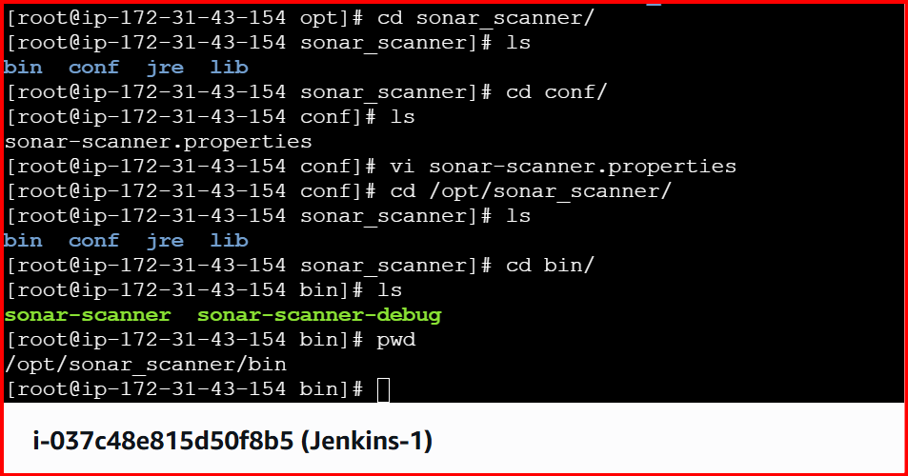

Pwd path should be give below

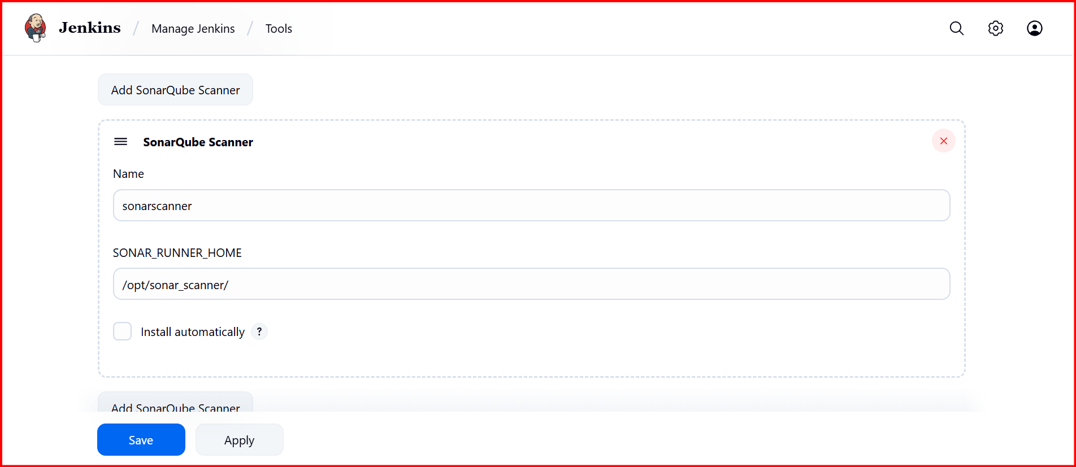

Path configuration properties

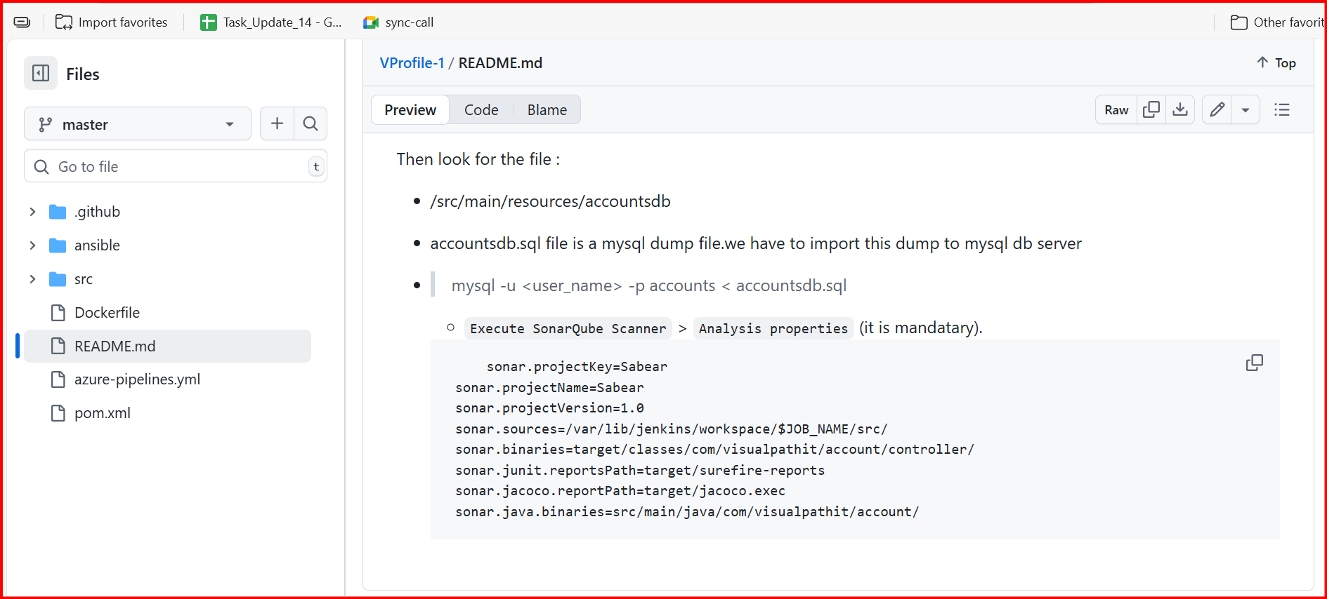

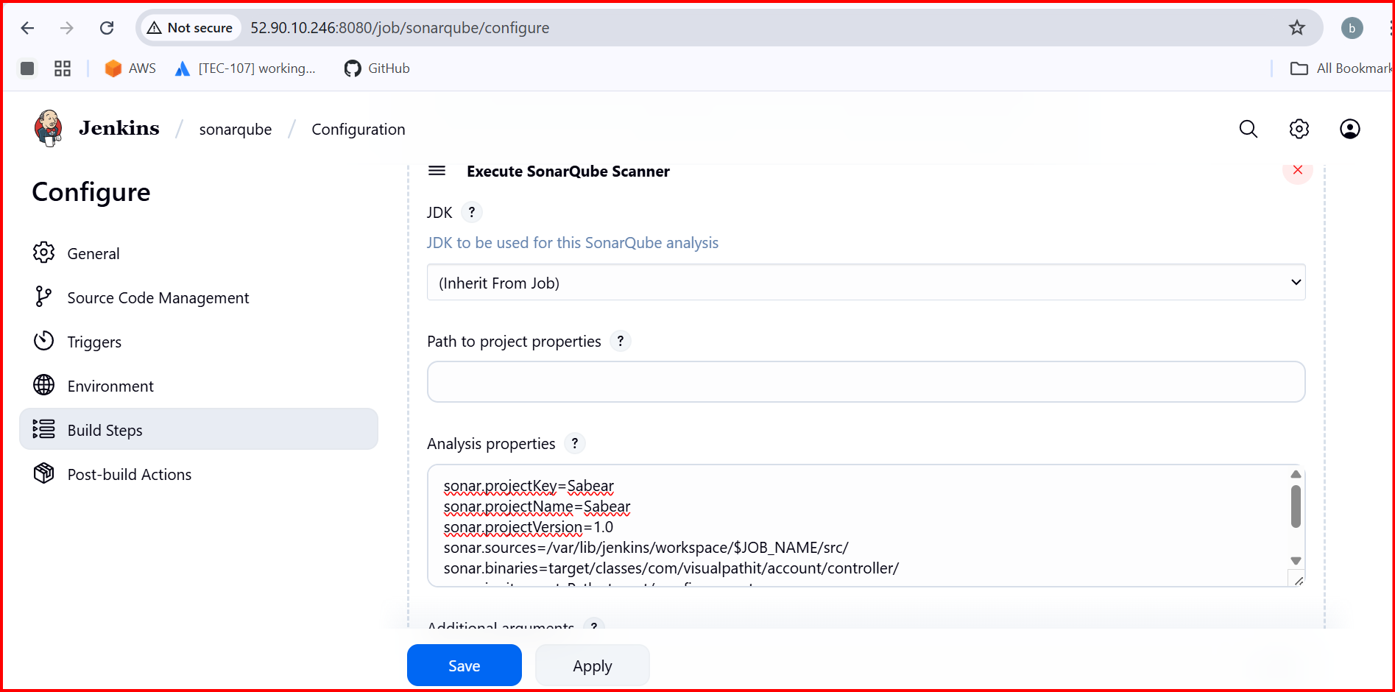

Build job now

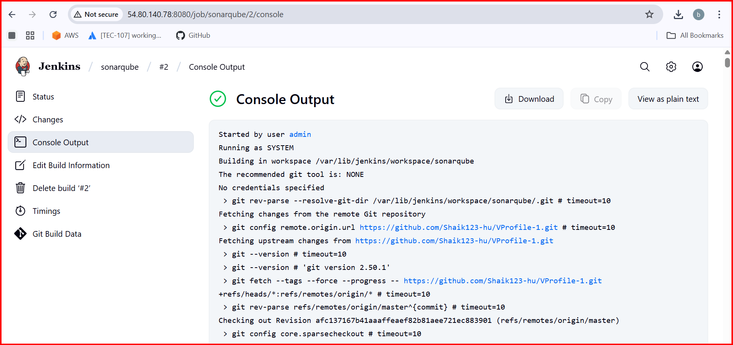

Check in sonarqube:

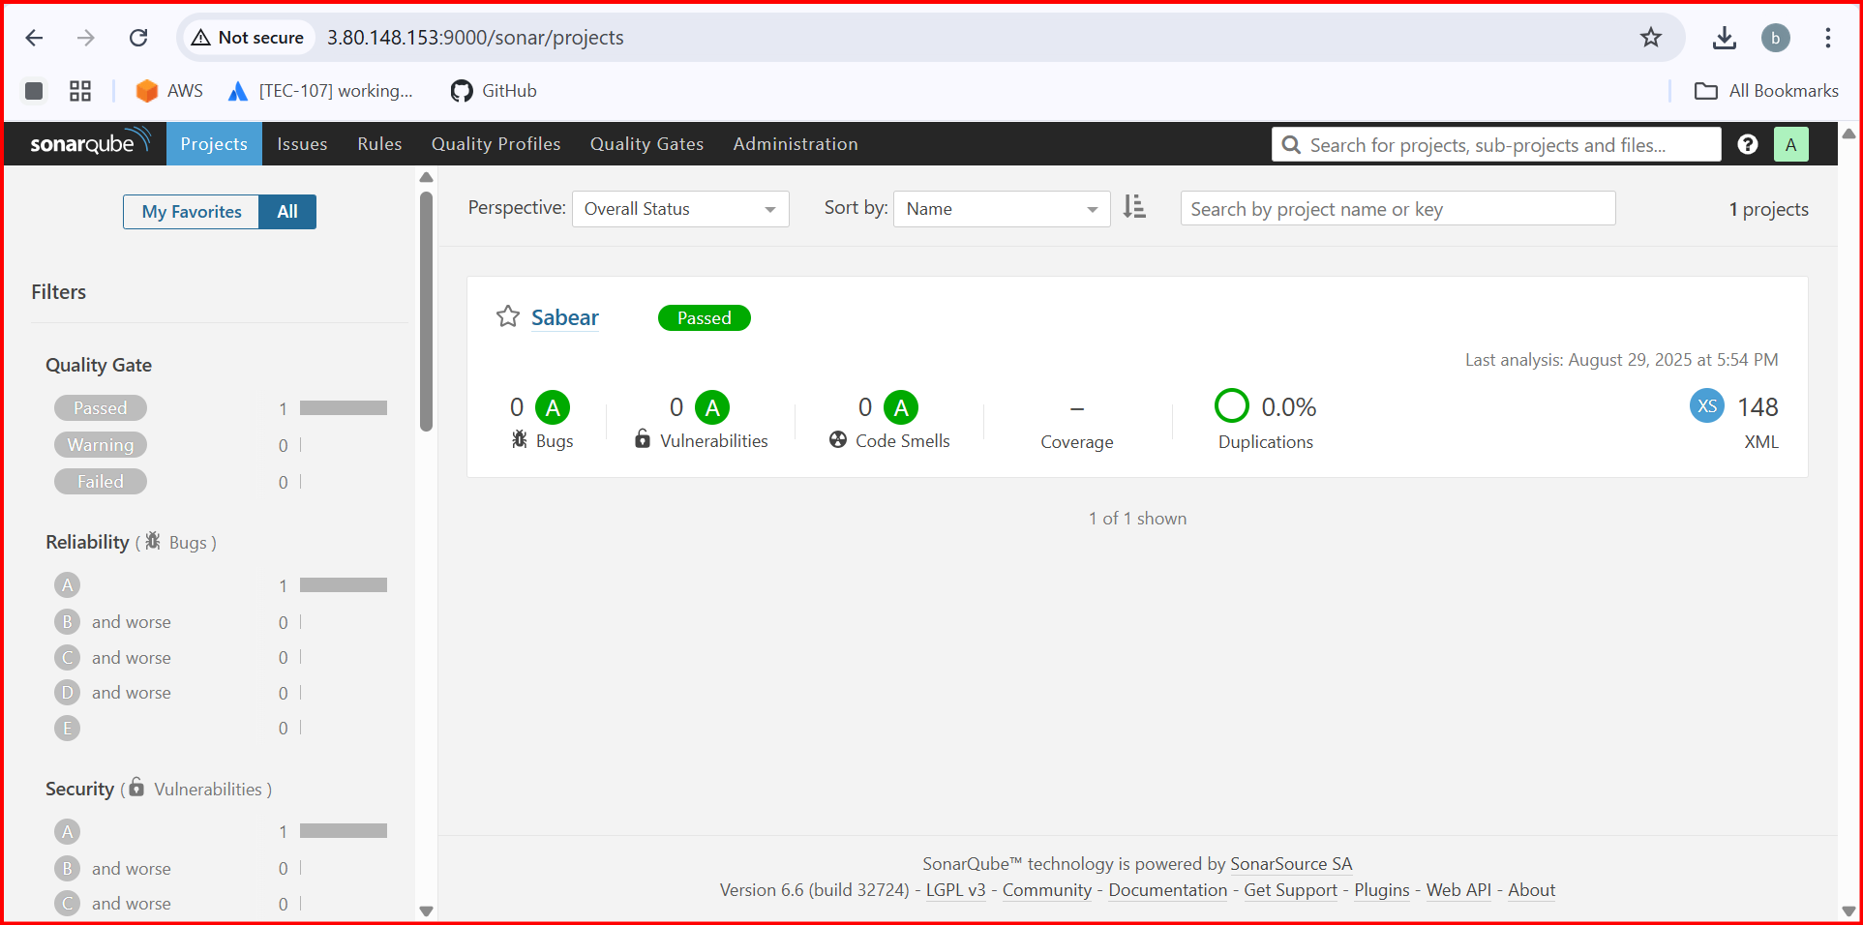

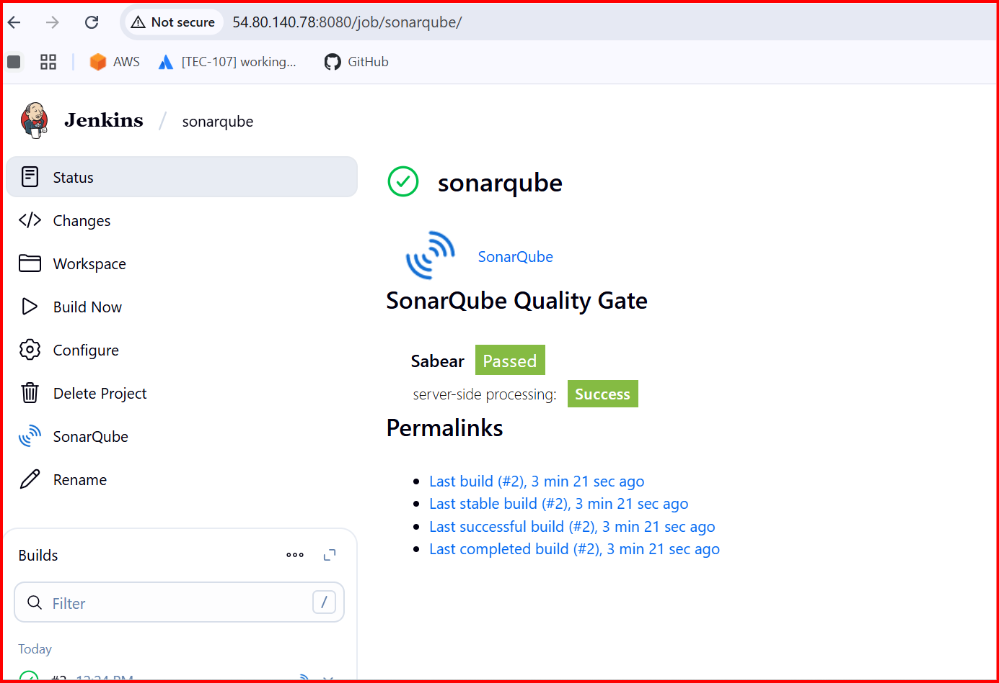

Slack Notification

Go to slack🡪 apps 🡪 Jenkins🡪 configured

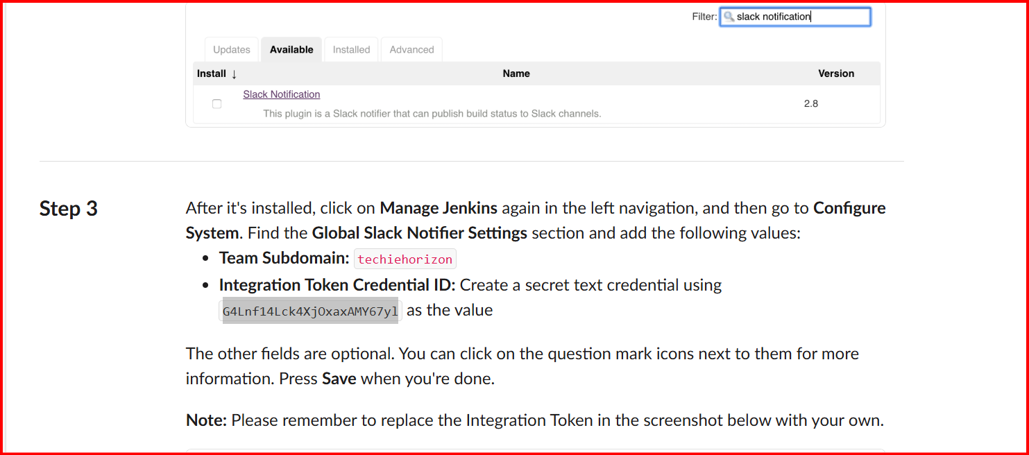

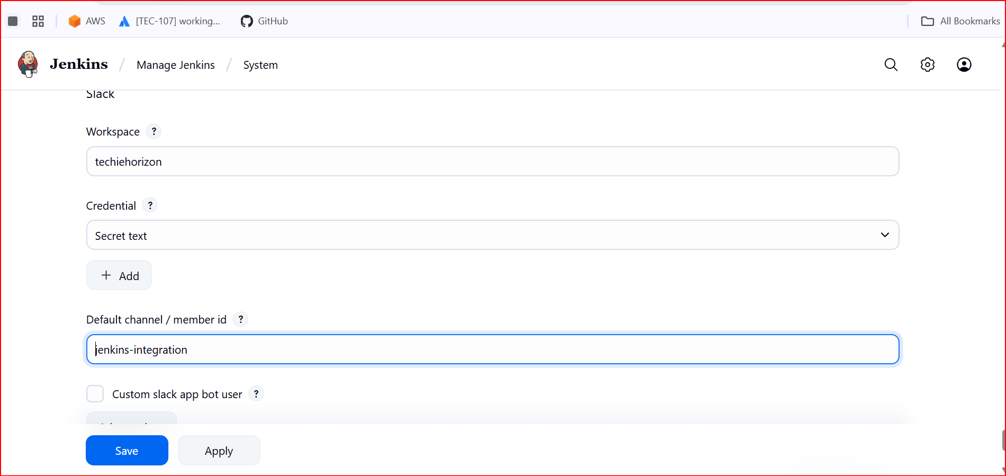

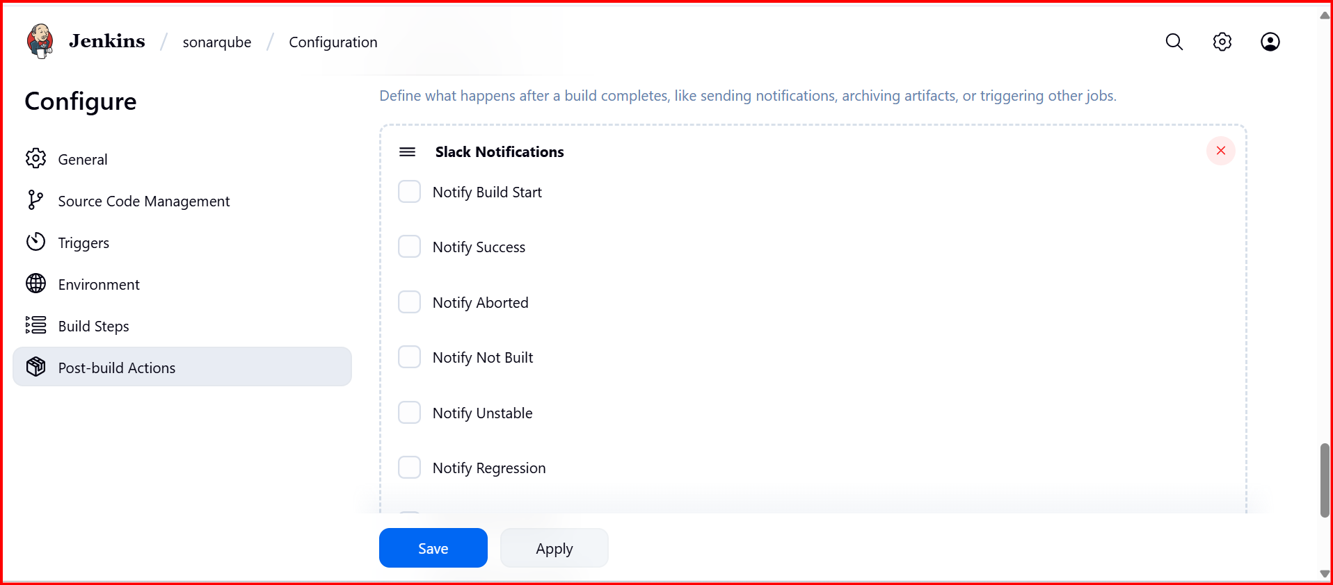

2. **Create one jenkins job using the below code and create three stages. stage1: Git clone to download the source code. stage2: Sonarqube Integration to check the quality of code stage3: Slack Integration to send the alerts to slack. URL:** [**https://github.com/betawins/hiring-app.git**](https://github.com/betawins/hiring-app.git)

Install Sonarqube and Jenkins

Create a job

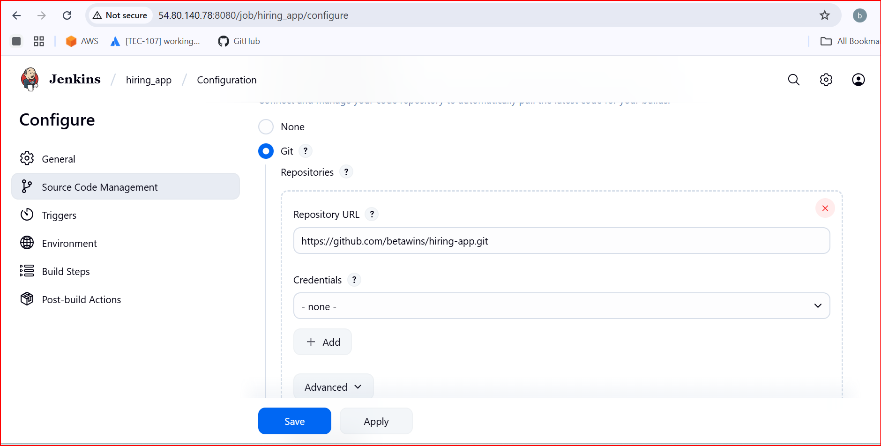

Add the Analysis properties (which will be available in source code)

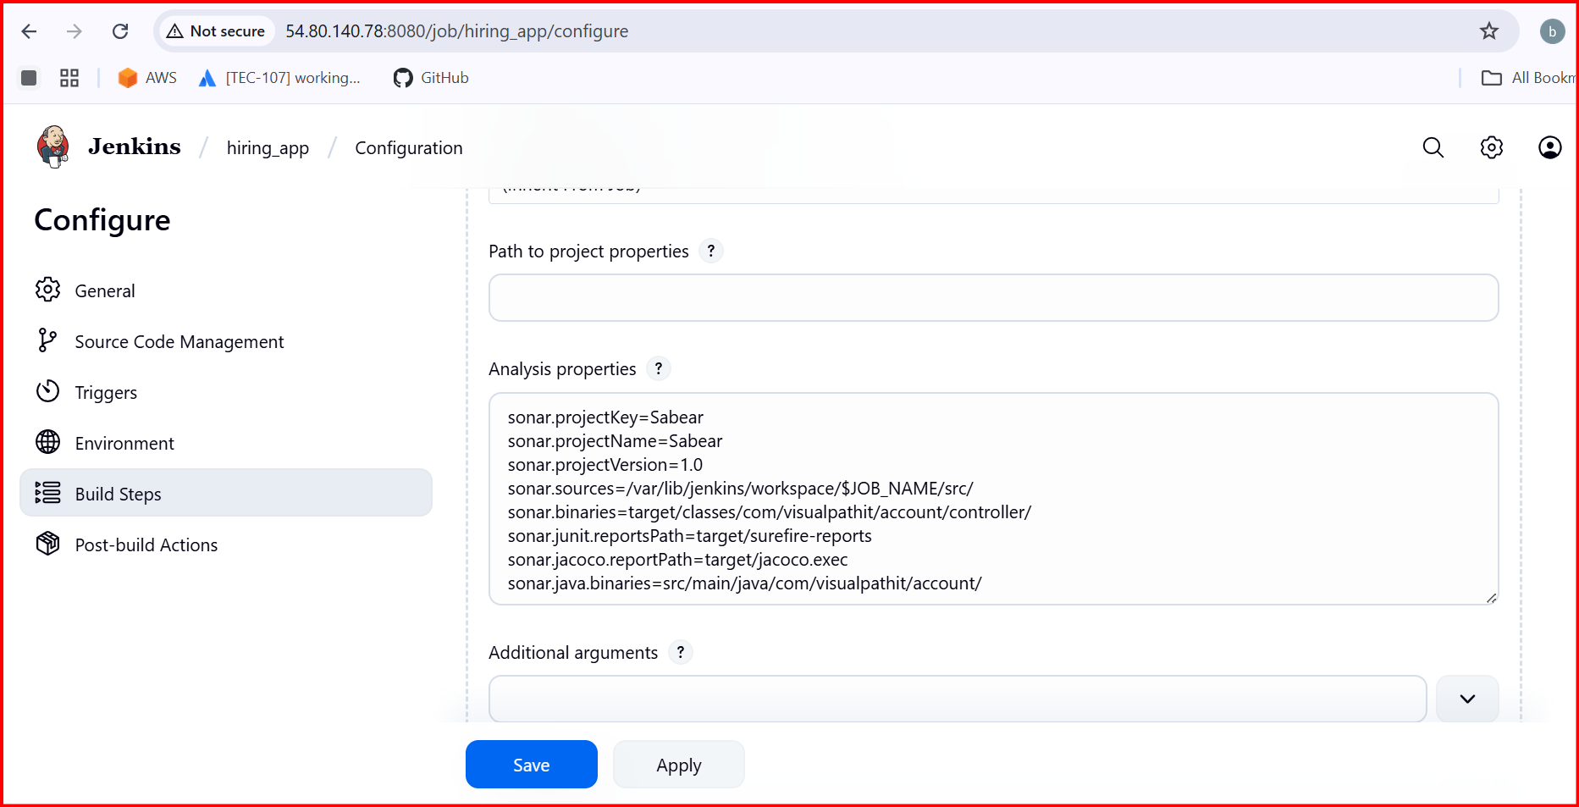

Then build now

